Week 2 Homework — Blue Group
Palm Oil: A Balancing Act in the Forest
In the rainforests of Sumatra and Borneo, a big conflict is happening between human needs and saving nature. The main cause of this problem is palm oil. Palm oil is a very useful oil used in many foods and soaps.
For ecologists, the growth of palm farms is a major disaster. Large areas of beautiful rainforest are cut down every day. This clears away the homes of many rare animals. Wild orangutans lose their food and nests when the trees are cleared. In the book Berani, a girl named Malia gives a speech. She talks about this sad problem. She explains that orangutans are in danger of dying out. Captive animals like Ginger Juice in Malang show what happens when forests are lost. Ecologists argue that we must protect the forests to save the Earth's climate and wildlife.
However, for millions of Indonesian farmers, palm oil is an important lifeline. Many small farmers grow palm fruit to support their families. The money they make from palm oil helps lift them out of poverty. It allows parents to pay for school fees and healthcare. As Malia’s mother reminds her, many families depend on this industry to survive. Farmers argue that they need to use their land to live. Also, banning palm oil might make things worse. Other oil crops need much more land to grow the same amount of oil. Today, people are trying to find a middle ground by growing sustainable palm oil.
Part A: Reading Comprehension
1. In which two places are the rainforests mentioned in the text located?
A. Jakarta and Toronto B. Malang and Surabaya
C. Java and Bali D. Sumatra and Borneo
2. What are two common items that use palm oil, according to the text?
A. Foods and soaps B. Clothes and shoes
C. Paper and pencils D. Cars and computers
3. Why do ecologists consider the spread of palm farms a disaster?
A. Because farmers do not earn enough money from it. B. Because the trees make the soil too wet.
C. Because palm oil is unhealthy for humans to eat. D. Because it causes large areas of rainforest to be cut down, destroying animal homes.
4. What happens to wild orangutans when the rainforest is cleared?
A. They are moved to schools by ecologists. B. They learn to live in the palm trees.
C. They migrate to other countries like Canada. D. They lose their food sources and their nests.
5. Who is Malia in the book Berani?
A. A farmer who owns a large plantation. B. Ari's aunt who runs a restaurant.
C. A scientist studying palm trees. D. A student who gives a speech about the orangutan threat.
6. What does the captive orangutan Ginger Juice show us?
A. How to make freshly squeezed juice. B. That orangutans are happy living in cages.
C. What happens when wild forests are lost. D. That mynah birds can sing rock songs.
7. Why is palm oil farming described as an 'important lifeline' for Indonesian farmers?
A. It is a very safe job with no hard work. B. It allows them to travel to other countries.
C. It lifts them out of poverty and helps them support their families. D. It helps them build larger schools.
8. What does the money made from palm oil help farmers pay for?
A. School fees and healthcare. B. Rainforest plants and trees.
C. Supermarket products and petitions. D. Cars and restaurant menus.
9. Who reminds Malia that many families depend on palm oil to survive?
A. Ginger Juice B. Her mother
C. Ari's uncle D. Her teacher
10. What do farmers argue about their land?
A. They do not want to grow any crops. B. They need to use it to live and support their families.
C. They want to sell it to ecologists. D. They want to plant soy instead of palm trees.
11. According to the text, why might banning palm oil completely make things worse?
A. Orangutans would lose their remaining forest homes even faster. B. Farmers would stop paying all taxes.
C. Other oil crops need much more land to grow the same amount of oil. D. The climate would become much hotter.
12. What is the 'middle ground' that people are trying to grow today?
A. Giant cages for all animals in Malang. B. Sustainable palm oil that balances human and nature needs.
C. Banning all soaps and foods that use oil. D. Organic soy and coconut farms.
13. Which of the following is NOT mentioned as a threat to orangutans?
A. Loss of nests in the canopy. B. Replacing forests with palm plantations.
C. Farmers feeding them too many bananas in cages. D. Loss of wild food sources.
14. Based on the passage, what is the main disagreement between ecologists and farmers?
A. How many hours a day children should spend at school. B. Whether to protect rainforests or clear them for farming income.
C. Which country makes the best oxtail soup. D. The price of supermarket products.
15. What makes the palm oil issue 'far from black and white'?
A. Both sides have strong, valid reasons for their viewpoints. B. The book Berani does not have a clear ending.
C. Palm oil itself is yellow and the trees are green. D. There are no laws in Indonesia about forests.

Part B: Mathematics Word Problems
16. A rectangular paddock has a length of 12 metres and a width of 7 metres. What is its perimeter?
A. 84 metres B. 38 metres
C. 19 metres D. 48 metres
17. A rectangular nature reserve has an area of 108 square kilometres. If its length is 12 kilometres, what is its width?
A. 8 kilometres B. 18 kilometres
C. 96 kilometres D. 9 kilometres
18. An L-shaped vegetable garden is made by joining two rectangular plots. Plot 1 is 8 metres long and 4 metres wide. Plot 2 is 5 metres long and 3 metres wide. What is the total area of the garden?
A. 32 square metres B. 40 square metres
C. 47 square metres D. 20 square metres
19. A square agricultural field has an area of 64 square metres. What is the perimeter of this field?
A. 16 metres B. 32 metres
C. 24 metres D. 64 metres
20. A rectangular reserve has a width of 15 metres and an area of 300 square metres. What is the perimeter of the reserve?
A. 150 metres B. 35 metres
C. 20 metres D. 70 metres
21. What is the perimeter of the compound shape shown in the diagram?
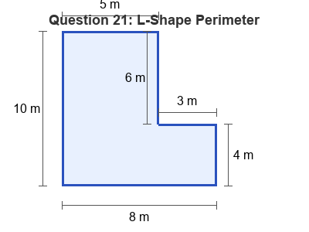
A. 28 metres B. 36 metres
C. 30 metres D. 40 metres
22. A farmer wants to fence a rectangular palm tree nursery that is 22 metres long and 18 metres wide. Fencing costs $8 per metre. What is the total cost of the fence?
A. $1280 B. $3168
C. $320 D. $640
23. A rectangular reserve has an area of 120 square metres. If the width of the reserve is 8 metres, what is the length?
A. 12 metres B. 112 metres
C. 30 metres D. 15 metres
24. What is the total area of the T-shaped compound zone shown in the diagram?
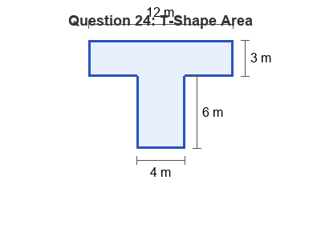
A. 72 square metres B. 48 square metres
C. 36 square metres D. 60 square metres
25. A square playground has a perimeter of 48 metres. What is the area of the playground?
A. 12 square metres B. 48 square metres
C. 96 square metres D. 144 square metres
26. A rectangular paddock is 20 metres long and has a perimeter of 60 metres. What is the area of the paddock?
A. 300 square metres B. 200 square metres
C. 800 square metres D. 400 square metres
27. What is the area of the remaining shape after the corner is removed?
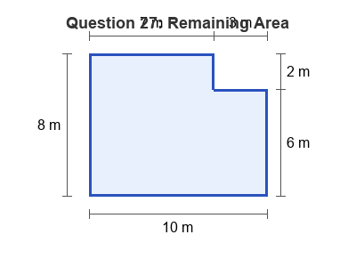
A. 86 square metres B. 80 square metres
C. 68 square metres D. 74 square metres
28. A rectangular classroom has an area of 72 square metres. If its length is 9 metres, what is its perimeter?
A. 34 metres B. 64 metres
C. 8 metres D. 17 metres
29. A square garden bed has an area of 100 square metres. If we double the length of its sides, what will the new area be?
A. 200 square metres B. 1000 square metres
C. 400 square metres D. 300 square metres
30. A rectangular courtyard measures 15 metres by 10 metres. A 1-metre wide brick path is built inside the courtyard, running all the way around the inner edge. What is the area of the brick path?
A. 150 square metres B. 104 square metres
C. 46 square metres D. 50 square metres

